Scripts for DUAS activity survey

Contents
1 Provided scripts 2
2 How does it work? Why to use these scripts? 2
3 How to use these scripts? 3
3.1 Environment 3
3.2 Command Line 3
3.3 Options 3
3.4 Output 3
4 Examples 4
4.1 No arguments 4
4.2 All arguments 5
4.3 Redirected to csv file 5
5 Thoughts 5

1 Provided scripts
- stat_fmhs.sh
- stat_fmcx.sh
- stat_fmhsV6.sh
- stat_fmcxV6.sh
- stat_fmhs_unix.sh
- stat_fmcx_unix.sh
- stat_fmhs_unixV6.sh
- stat_fmcx_unixV6.sh

2 How does it work? Why to use these scripts?

Dollar Universe keeps record of launches in 2 main files
- u_fmhs50.dta: The execution history file keeps record of launches and history traces for all launches of every job.
- u_fmcx50.dta: The job runs file keep records of execution of every job.
(nb: in DUAS V6, files are named u_fmhs60.dta and u_fmcx60.dta, their structure may differ a bit)

Basically, when a job is launched, every change of state, variable settings, and messages are kept in fmhs, this is the main statistic file. If a job does not fulfil the condition for its launch, a new record is created in fmhs, under a new numproc. Numproc is the main key of fmhs; fmhs should have record for every numproc (until it is purged).

Once a job is ended, its execution result is written in fmcx. Numproc is also the main key of fmcx, but fmcx keep record only for launches that have been running, thus, not all numproc are present in fmcx.

The provided scripts, stat_fmhs.sh and stat_fmcx.sh, give informations about the number of launches, and the number of ended jobs, then, it is possible to see how many launches are done in an area of a company from fmhs, how many executions are done in an area of a company, and compare the numbers in order to see if there are a lot of relaunches (scheduled launches that don’t become a running job because their conditions are not fulfilled).

3 How to use these scripts?

3.1 Environment
These scripts are written in bash, and use gawk.
Gawk is a GNU version of awk, with advanced functions on dates, which are used in the scripts. Gawk is available on all linux, but not in all unix. Actually, most unix system don’t have gawk.
A unix version of the scripts using ksh and simple awk exists, with homemade date functions. It seems to work quite well, but if possible, use the gawk versions.
Under Microsoft Windows, you can use the very good “cygwin”, which provide full linux environment with bash and gawk.

3.2 Command Line
The simplest way to use these scripts is to copy them in the same directory as your “.dta” files, and to launch them from a bash prompt. The output will be written on the standard output.

3.3 Options
If launched without arguments, the script will find first and last date mentioned in the file, and give an output with the number a launches (for fmhs) or executions (for fmcx) per hour for the full time period.
With options, you can choose:
  - The starting timestamp: option “-s”. Format: YYYYMMDDHHmm
  - The ending timestamp: option “-e”. Format: YYYYMMDDHHmm
  - The targeted file: option “-f”. Format: /path/to/my/file
  - The time unit: option “-t”. Format:
      - « m » : 1 minute
      - « dix » or « ten » : 10 minutes
      - « h » : 1 hour (default)
      - « j » or « d » : 1 day
If you use a non existing option, you will get a small help, in French :D

3.4 Output
The output is formatted in csv microsoft style (separated by semicolon rather than coma), thus, by redirecting the output to a .csv file, you will be able to open it with your favourite spreadsheet software and create nice graphs.

4 Examples

4.1 No arguments
The whole file will be treated by hours:
# ./stat_fmcx.sh
"2012/12/19--16:00";11
"2012/12/19--17:00";11
"2012/12/19--18:00";21
"2012/12/19--19:00";3
"2012/12/19--20:00";0
"2012/12/19--21:00";0
"2012/12/19--22:00";102
"2012/12/19--23:00";7
"2012/12/20--00:00";18
"2012/12/20--01:00";5
"2012/12/20--02:00";3
"2012/12/20--03:00";4
"2012/12/20--04:00";5
"2012/12/20--05:00";1
"2012/12/20--06:00";2
"2012/12/20--07:00";11
"2012/12/20--08:00";13
"2012/12/20--09:00";11
"2012/12/20--10:00";0
"2012/12/20--11:00";11
"2012/12/20--12:00";17
Etc...
"2013/01/02--22:00";113
"2013/01/02--23:00";18
"2013/01/03--00:00";29
"2013/01/03--01:00";6
"2013/01/03--02:00";6
"2013/01/03--03:00";0
"2013/01/03--04:00";7
"2013/01/03--05:00";1
"2013/01/03--06:00";0
"2013/01/03--07:00";0
"2013/01/03--08:00";2
"2013/01/03--09:00";23
"2013/01/03--10:00";0
"2013/01/03--11:00";11
"2013/01/03--12:00";28
"2013/01/03--13:00";9
"2013/01/03--14:00";3
"2013/01/03--15:00";11
"2013/01/03--16:00";12

4.2 All arguments
From 3rd of January 2013 11 AM to 3rd of January 2013 1PM by ten minutes shift:
# ./stat_fmcx.sh -s 201301031100 -e 201301031300 -t ten -f ./u_fmcx50.dta
"2013/01/03--11:30";11
"2013/01/03--11:40";0
"2013/01/03--11:50";0
"2013/01/03--12:00";6
"2013/01/03--12:10";11
"2013/01/03--12:20";0
"2013/01/03--12:30";0
"2013/01/03--12:40";0
"2013/01/03--12:50";11

4.3 Redirected to csv file
From 2nd of January to end of file, all minutes, Redirected to csv, with graph (graph was quickly done with excel by selecting the 2 columns):
# ./stat_fmcx.sh -s 201301020000 -t m -f ./u_fmcx50.dta > executions.csv

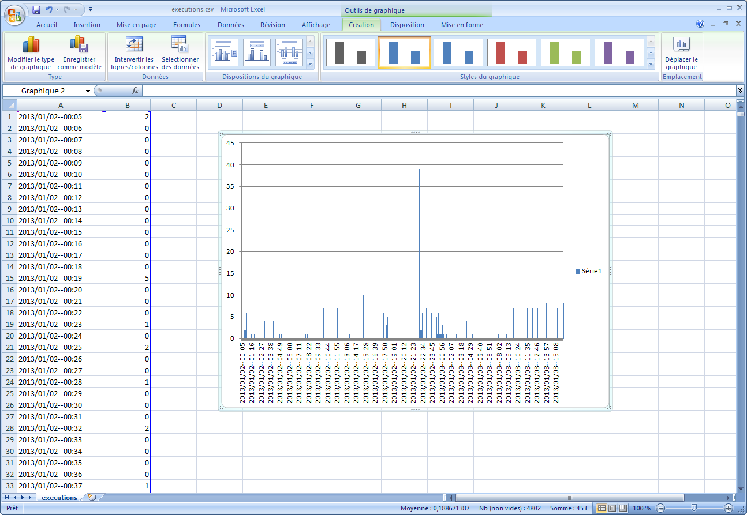

5 Thoughts
If you see an improvement that could be useful for customer service, or if you encounter a bug, feel free to send an email to jke@orsyp.com

